









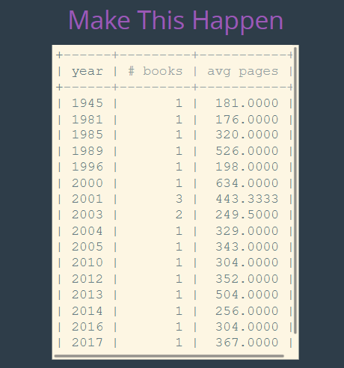

**The solutions:**

select * from books;

select count(*) from books;

select released_year, count(*) from books group by released_year order by released_year;

select sum(stock_quantity) from books;

select author_fname, author_lname, avg(released_year) from books group by author_fname, author_lname;

select concat(author_fname, ' ', author_lname) as author, pages from books

where pages = (select max(pages) from books);

select released_year as 'year', count(*) as '# books', avg(pages) as 'avg pages' from books group by released_year order by released_year;